JAPANESE PREHISTORY
Kofun Period:
The Kofun Period of Japan lasted from 250 AD to around 538 AD. The era was named after the Kofun burial mounds found in the Tanegashima Island .These mounds were built for the royalty and the stone chambers were protected by the use of moats. The recorded history of Japan commences with the Kofun Period. The Asuka period closely followed the Kofun and together they are known as the Yamato period of Japan. The Yamato land is believed to have included the Tanegashima and Yakushima Islands.
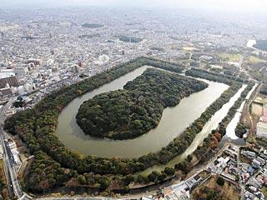
Kofun burial mound
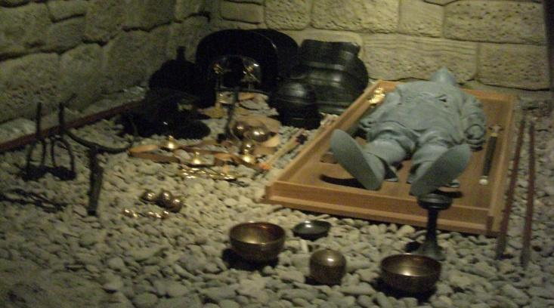
Inside the burial chamber of Shougunyama kofun (a reconstruction), Saitama Prefecture

THE ASUKA PERIOD (552 AD and 710 AD)
Architectural changes during the Asuka period was the introduction of Buddhism. The term "asuka" was first used to describe a time in Japan of their fine-arts and architecture. This period was mainly influenced by Buddhism from China and Korean Peninsula. Japan's main religion at that time was the Shinto religion. So during this time not only the architecture was changed, but also the fundamental base of their religion; Buddhism.
MATERIAL:
Japan at that time had very beautiful natural scenery, in which the forests were orderly mannered and tamed, so their buildings were built out of natural materials such as wood to complement the nature and not to protest against it.
Unfortunately many of these stunning traditional temples have been burnt down due to the primary material being wood.
The structure of many buildings were also represented and symbolized many different things. An example of this was the five story Pagoda. The five stories represented the five elements: Earth, Water, Fire, Wind, Sky.
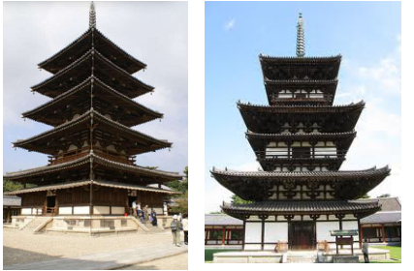

In early temple-building, the pagoda was of symbolic importance and usually was placed in a central position. In Asuka, multiple golden halls usually surrounded a central pagoda in the late 6th century at Asukadera, but later the pagoda lost its importance and became more ornamental so that in later 7th century designs, two or more pagodas would frame a centrally positioned golden hall instead.
Some of the elements that clearly indicate the Asuka style of architecture found in the four oldest Horyuji structures are:
- the cloud-pattern bracket arms that support the eaves of pagodas
- a slight convex line on the pagoda columns (called entasis); 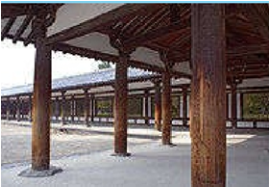
- the stylized swastika pattern in the ornamental railings;
- the inverted V-shaped struts beneath them.
Characteristics of Hōryū-ji Temple
The Horyu-ji temple complex is considered the oldest wooden structure in the world. Originally completed in 607 and reconstructed in 670 AD, the temple exemplifies Japanese temple architecture of the Asukaperiod.

- Three essential buildings in any temple complex:
- a five storied pagoda (Gojuno-do),
- a Great Hall (Kondo),
- a monastic study hall (Kodo).

Pagoda
The five-story pagoda, located in the Sai-in area and standing at 32.45 meters (122 feet), is one of the oldest wooden buildings in the world.
A tiered tower with projecting roofs ♣ an evolution of the Indian Stupa( a building to enshrine the cremated remains of Buddha: ashes and bone fragments) ♣ It functions the same as the stupa,
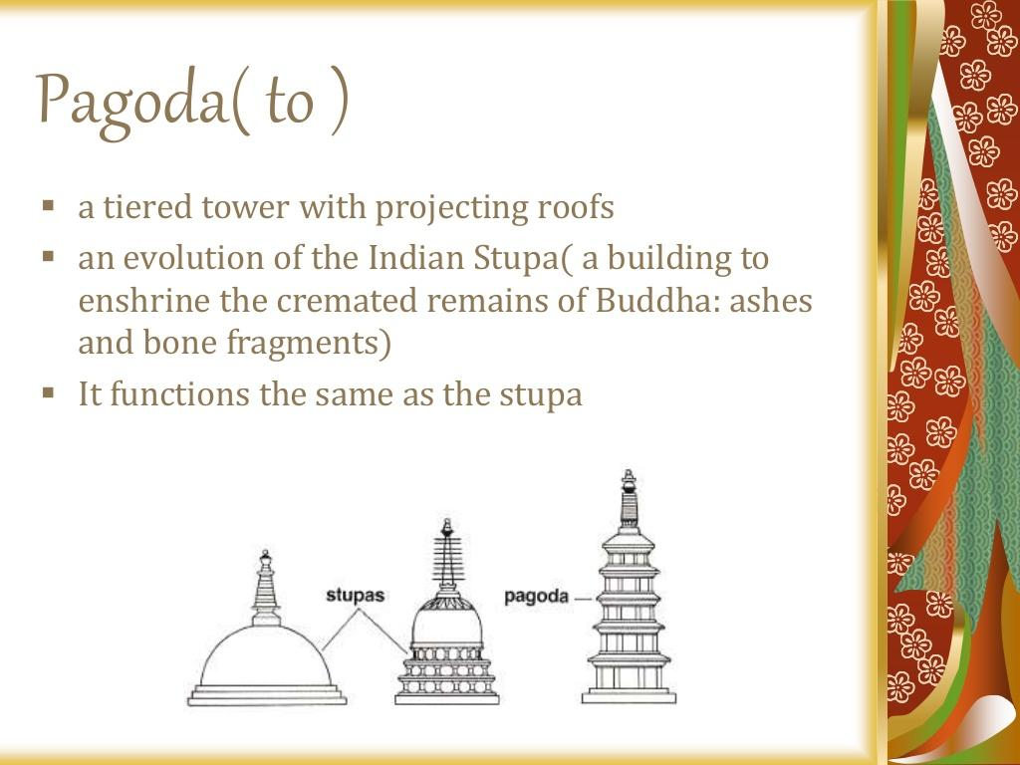

The central pillar rests three meters below the surface of the massive foundation stone, stretching into the ground. At its base is enshrined what is believed to be a fragment of one of Buddha's bones. Around it, four sculpted scenes from the life of the Buddha face north, east, south, and west. Although the pagoda is five-storied, it does not allow one to climb up inside, but it is rather designed to inspire people with its external view.
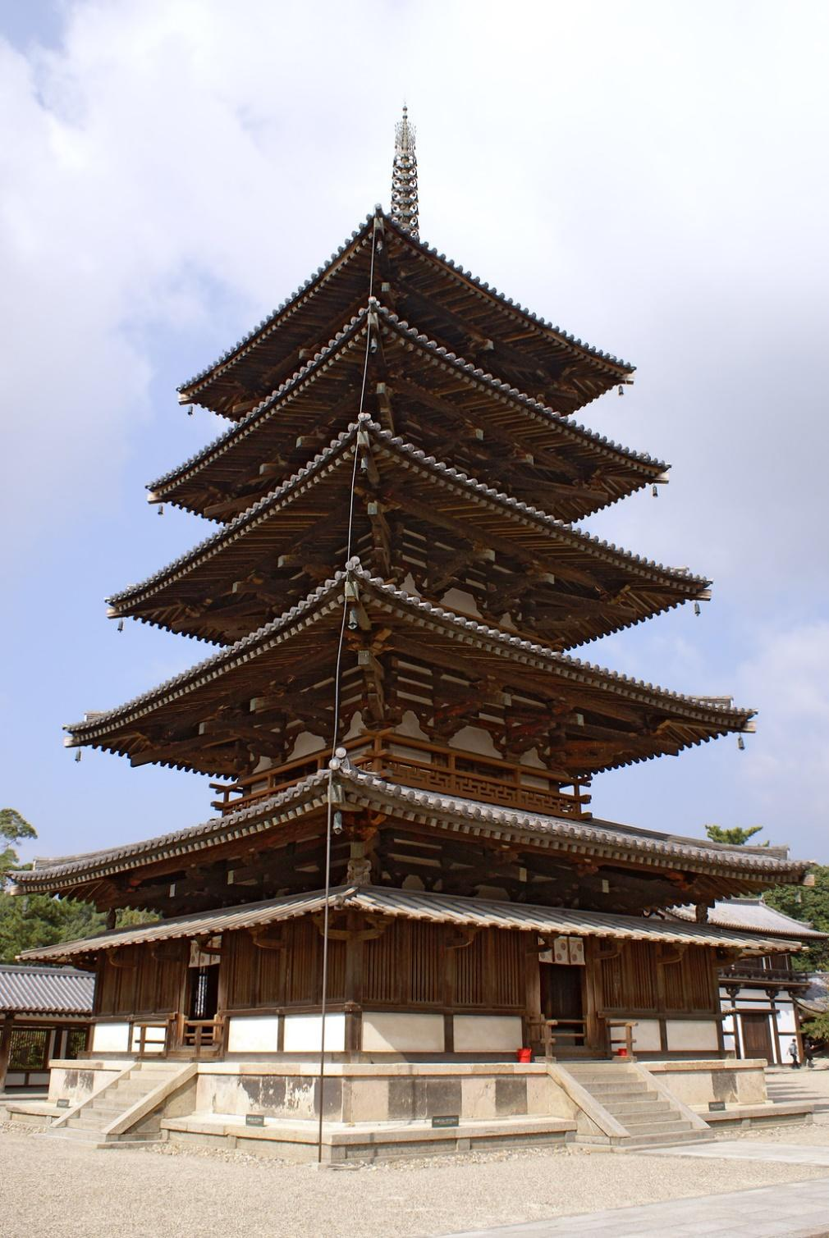
Hōryū-ji pagoda
- The five-storied pagoda has certain characteristics unique to Hōryū-ji.
- Floors are raised above ground to reduce humidity
- There are stairways of entrance from each of the four directions

- Bracket support
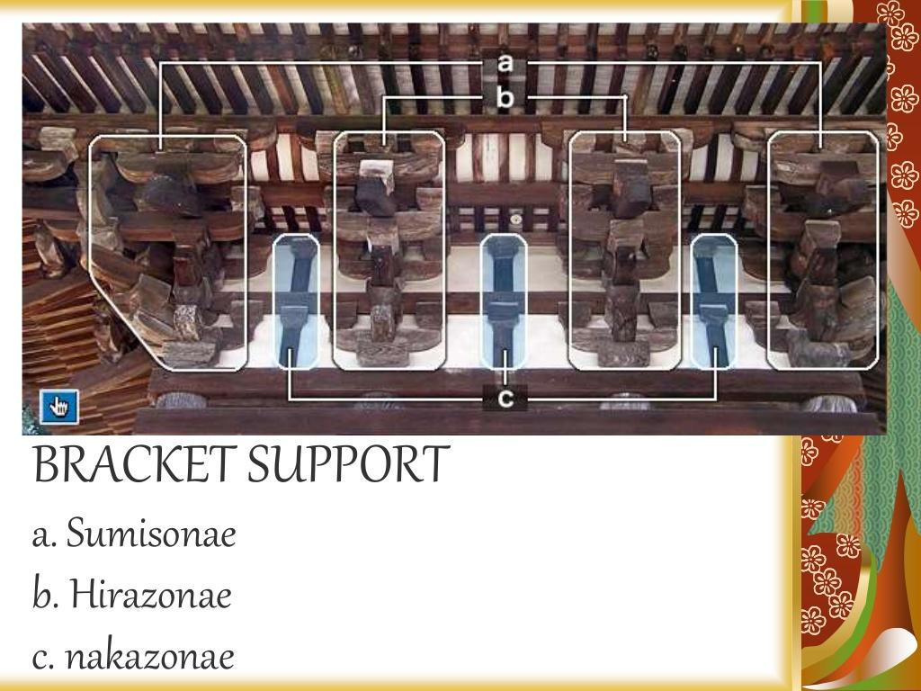
- EAVAES
Eaves are long to create shadows for summer
Steep roofs to allow quick rain and snow runoff

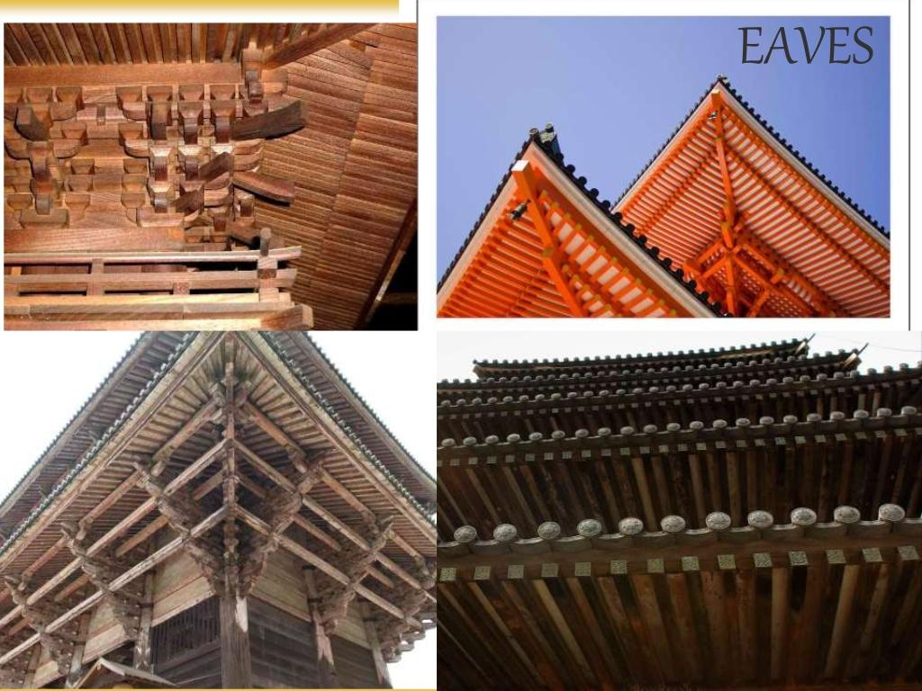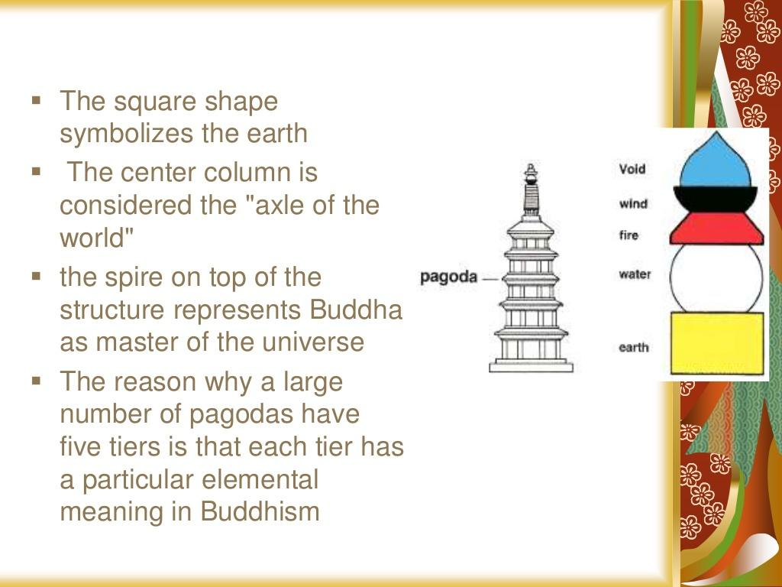

KONDO
The kondō, located side-by-side to the pagoda in Sai-in, is another one of the oldest wood buildings extant in the world . The hall measures 18.5 meters by 15.2 meters. The hall has two stories, with roofs curved in the corners. Only the first story has a double roof (裳 mokoshi). This was added later in the Nara period with extra posts to hold up the original first roof because it extended more than four meters past the building. The hall holds the famous Shaka Triad, together with a bronze Yakushi and Amida Nyorai statues, and other national treasures.
While the main altar faces south, less important statues face the other cardinal directions to stress the importance of radiating towards all directions. TheKondo also uses wood columns that utilize a slight entasis and support a cluster of brackets that are required to carry the weight of the large roof structure that is further burdened with the use of tiles as opposed to the traditional roof material of choice, wood or thatch.
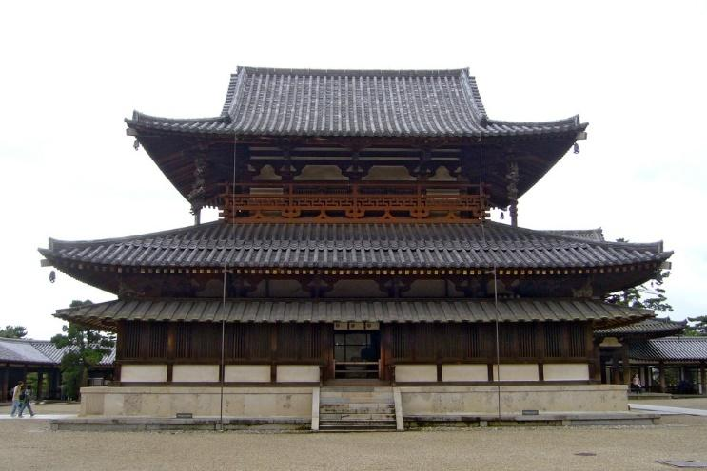
The kondō of Hōryū-ji
The two-storied kondō is another one of the oldest wood buildings extant in the world.
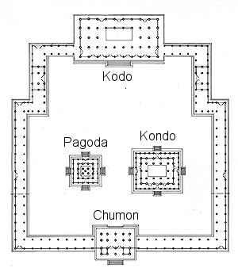

HEIAN PERIOD
In reaction to the growing wealth and power of organized Buddhism in Nara. Japanese Buddhist architecture also adopted the stupa in its Chinese form of pagoda.
The temples erected for this new sect were built in the mountains, far away from the court. Cypress-bark roofs replaced those of ceramic tile, wood planks were used instead of earthen floors, and a separate worship area for the laity was added in front of the main sanctuary.
The Hōō-dō (Phoenix Hall, completed 1053) of the Byōdō-in, a temple in Uji to the southeast of Kyoto, is the exemplar of Fujiwara Amida halls. It consists of a main rectangular structure flanked by two L-shaped wing corridors and a tail corridor, set at the edge of a large artificial pond. Inside, a single golden image of Amida (circa 1053) is installed on a high platform. The Amida sculpture was executed by Jocho, who used a new canon of proportions and a new technique (yosegi), in which multiple pieces of wood are carved out like shells and joined from the inside. Applied to the walls of the hall are small relief carvings of celestials, the host believed to have accompanied Amida when he descended from the Western Paradise to gather the souls of believers at the moment of death and transport them in lotus blossoms to Paradise. Raigo (Descent of the Amida Buddha) paintings on the wooden doors of the Ho-o-do are an early example of Yamato-e, Japanese-style painting, because they contain representations of the scenery around Kyoto.
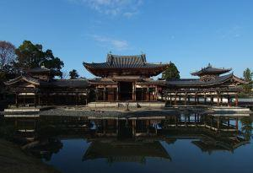
Phoenix Hall at Byodoin, Uji, Kyoto
Built in 1053
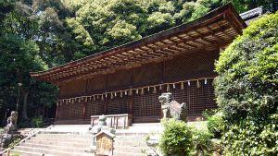
Ujigami Shrine, Uji, Kyoto
Built in 1060
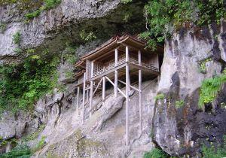
Nageiredō of Sanbutsuji, Misasa, Tottori

“EDO PERIOD”

Architecture
- Edo period architecture erecting grand, elaborate structures for public display, while using modest, simple designs for private dwellings.
- Tried to reduce structures to their bare essential forms.
- Samurai Residences were built in this period (1603-1867).
- During the Edo Period, the Samurai were required to reside in the castle towns that surrounded the castles.
- Strict regulations had to be followed; for example:
- The size of the pillars and the type of gates to be used were pertained by status.
- While higher ranking samurai lived closest to the castle in large houses with spacious rooms and gardens.
- Lower ranking samurai had residences away from the castle.
- Naturally, only mansions of high ranked samurai were preserved overtime.

Shrines:

- The religious “Shinto” ceremonies were held in shrines. Early Shrine buildings predate the introduction to Buddhism and reflect Japanese architectural styles.
- Early shrine construction prototypes which already show more distinct foreign elements.
- Example: TOSHUGO SHRINE
Tosho
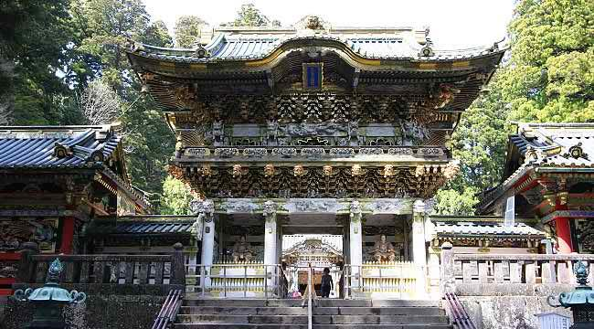
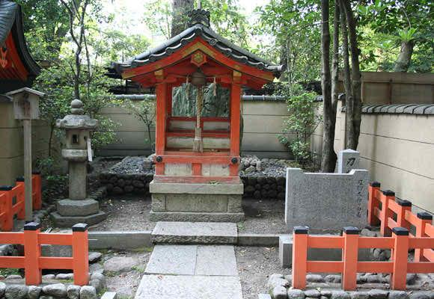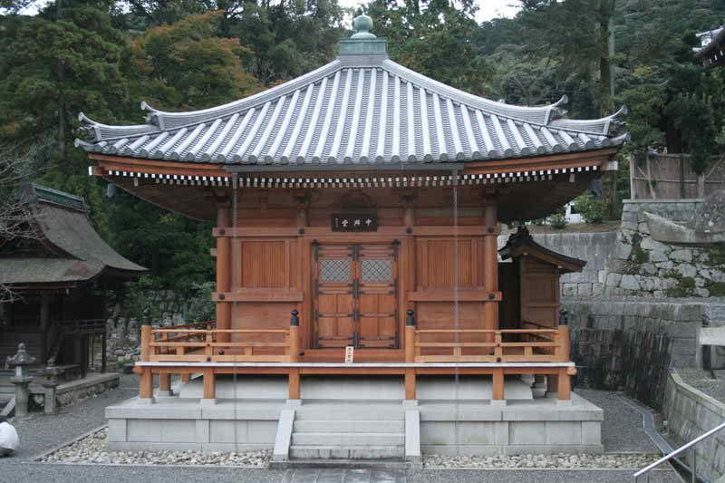

Palaces:
- Civil war (14th to 16th C) with the arrival of peace feudal lords started to build palaces for themselves.
- Situated within the castles separated from the main halls, served as residences, offices and reception halls. Example Nijo castle.
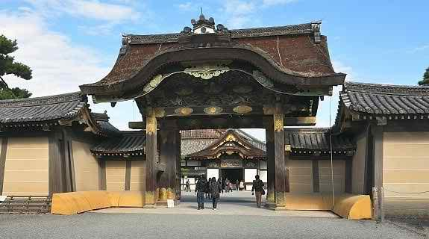

Castles:
- The civil war also gave the impetus for the construction of castles.
- Initially built for purpose of fortification.
- The primary material for castle construction used to be wood, but most of the rebuilt castles were constructed using ferro concrete, and thus they look authentic from the outside but not from within.
- Example: Himeji Castle and Matsumoto Castle.
SCULPTURE
- In the Edo period, two wandering (itinerant) monks of great modern fame revived a carving technique known as Natabori 鉈彫 (hatchet carvings, popular from last half of the 10th century to around the 12th century).
- Nearly all of their extant pieces were carved from a single block of wood and were not hollowed out.
- This gives their pieces a freshness that is completely different from the refined works of traditional Buddhist sculpture.

PAINTING

- The Battles of Hogen and Heiji:
- The two civil wars that occurred in the Hogen and Heiji eras took place in 1156 and 1160.
- The fighting lasted only a few days in each case, and it involved only a handful of politically eminent figures of the Heike (also known as the Taira) and Genji (also known as the Minamoto) clans.
- Yet, historically speaking, these are two of the most memorable insurrections of medieval Japan; they signaled the collapse of an old world order and the coming of a new era.
- Bloodcurdling incidents of these two wars, mixed with romantic interludes, became the basis for the first historical war novel of Japan, the Hogen monogatari (Tale of the Hogen Incident).
- The Hogen monogatari focuses on the decline of the once supremely powerful Fujiwara aristocrats and the rise of the two military families, the Genji and the Heike.
- The Heiji monogatari, on the other hand, describes the jealousy and inevitable conflicts between these two warrior clans, as well as the temporary defeat of the Minamoto family.
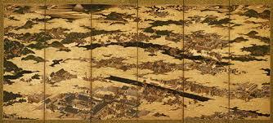

THE MEIJI PERIOD

- Farmers made up the majority of Japan's architecture in the Meiji Period (1868-1912).
- The Meiji Restoration of 1868 saw an influx of Western concepts on almost all aspects of life, from clothes to food, entertainment to architecture.
- Brick buildings are legacies left behind from this era, and they can be found especially at the handful of port towns that were early opened to international trade, such as Yokohama, Kobe, Nagasaki, Hakodate and Moji.
- Japanese architecture adopted the styles techniques and materials of Western style stone and brick architecture. And with the progress of the industrial revolution it paved the way to modern architecture of steel, concrete and glass.
- Addressed the combination of Western and European ideas and technology that were making their way into the cultural tapestry of Japan.
Farmhouse:
- Different farmhouse construction styles developed according to widely varying weather patterns.
- However, architectural similarities can be seen between dwellings across the country, such as the:
- Wooden facades
- Thatched roofs
- Sunken hearths (irori)
- Earth floors for stable and kitchen and
- Build Living spaces on elevated wooden floors that may have included some tatami rooms in case of the more well-off families.
- Numerous among the old buildings but were rarely preserved.
- THE OPEN AIR MUSEUM: Open air museums are also good places to see regional styles of farmhouses.

Sculpture:
During the Meiji, metalworkers made vases, sculptures, and other decorative objects for their new clients in Japan and abroad.
Japanese artists working in bronze and other metals.

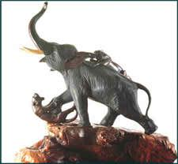
Pair of Incense Burners:
The shape of these incense burners shows the influence of Victorian silver designs, resembling large urns, or kettles that one might find in a Western interior.
Each burner stands on five legs that grow out of the mouth of monsters.
There are two dragons for handles, and another sitting on the lid. Incised both front and back with Japanese motifs, they are an example of Japanese interpretation of the confusion of Victorian designs that were introduced to Japan during the Meiji period.
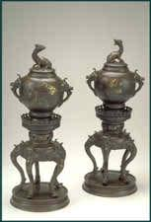

INCENSE CEREMONY BOX:
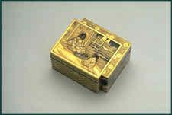

This rectangular, gold-decorated, copper covered box is in the form of two intersecting boxes.
The central decoration of a an elderly man facing a young child holding a plum branch may be an allusion to the artist-poet Sugaware-no-Michizane, chancellor to the 9th century Emperor Daigo.
The box, intended for use during the incense game, is decorated in several colours of gold.

PAINTING:
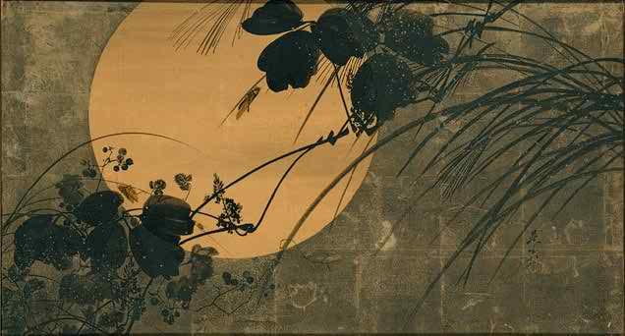
Autumn Grasses in Moonlight (1868–1912):
Autumn, with its melancholy mood and its aura of sadness, grief, loneliness, and even death, has always evoked a sense of regret for the passing of time.
On this two-panel screen, a variety of autumn grasses and flowers touched with dewdrops are brushed in ink, with grasshoppers and crickets painted in lacquer against a muted ground of silver leaf.
The plain paper surface has been left in reserve for the full moon.A few strokes of ink wash across the surface of the moon suggest a light haze.

- Fireflies over the Uji River by Moonlight:
- This atmospheric picture of shining fireflies traveling above the grass-flanked Uji River in a distant suburb of Kyoto derives its theme from the famous eleventh-century novel The Tale of Genji (Genji monogatari) by Murasaki Shikibu.
- A widowed prince who is a devout Buddhist and lives in the secluded suburbs along the Uji River with his two young daughters.
- A central scene in the chapter tells of a clandestine visit by a youthful male courtier and his attempts to overhear the music and conversation of the two young ladies.
- The courtier secretly listens outside their veranda in the dark night.
- He is hindered, however, by the loud noise of the rushing Uji and by the night's rain and heavy mist.
- The inky night and heavy atmosphere of the story are conveyed in this painting by the dark sky, and the clamor of the Uji is suggested by the streaming water and the wind-swept reeds.
Kamakura Period(1185-1333)
- is a period of Japanese history that marks the governance by the Kamakura shogunate
- officially established in 1192 AD in Kamakura, by the first shogun Minamoto no Yoritomo
- The period is known for the emergence of the samurai, the warrior caste, and for the establishment of feudalism in Japan
Architecture
- The Kamakura period took place during 1185-1333. This was when technology was becoming more involved with architecture, and this is how technological advances were made through building. Also due to the During the native requirements like earthquake resistance many architecture designs were unique, new and quite experimental. .
- During the Genpei War (1180–1185), many traditional buildings in Nara and Kyoto were damaged which made the people have to re-build shrines, which came out to be much simpler and down to earth, like the Hein period, but it was even simpler than the buildings then! This was also because their top priorities were military orders and not buildings
- The defense and protection that the buildings provided became a top priority, which meant that all the buildings were thatched under one big roof, than scattered around the garden.
- New residences used a buke-zukuri style that was associated with buildings surrounded by narrow moats or stockades
- Tea houses also became popular during this period, to reduce the tension and stress. They were very small spaces, held up by pillars and conservative materials. It was said that tea houses were always supposed to be around an atmosphere of calmness and meditation. The only decorations that would usually be in the tea house were calligraphy scrolls or flowers
- Even the architecture of this period became simpler. Many Zen temples were built during this time
- Painted portraits also appeared during this time
- The Kamakura period (1185–1333) brought to power the warrior caste, which expressed in its religious architecture its necessities and tastes
- In architecture this period is characterized by the birth of fresh and rational designs
- The Daibutsu style(Thick woodwork and imposing general look use of penetrating tie beams, great Buddha style)
- Thick, visible structural elements with decorative function
- As already mentioned, many structural elements are left uncovered and have a decorative function. For example, the roof's supporting members are not covered by a ceiling and are therefore fully visible from within the temple.
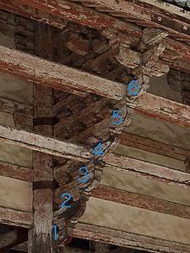
- the Zen style emerged in the late 12th or early 13th century

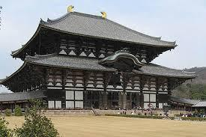
- The Zen style characteristics are earthen floors, subtly curved pent roofs cusped windows (katōmado) and paneled doors.
- Examples of this style include the belfry at Tōdai-ji, the Founder's Hall at Eihō-ji and the Shariden at Engaku-ji
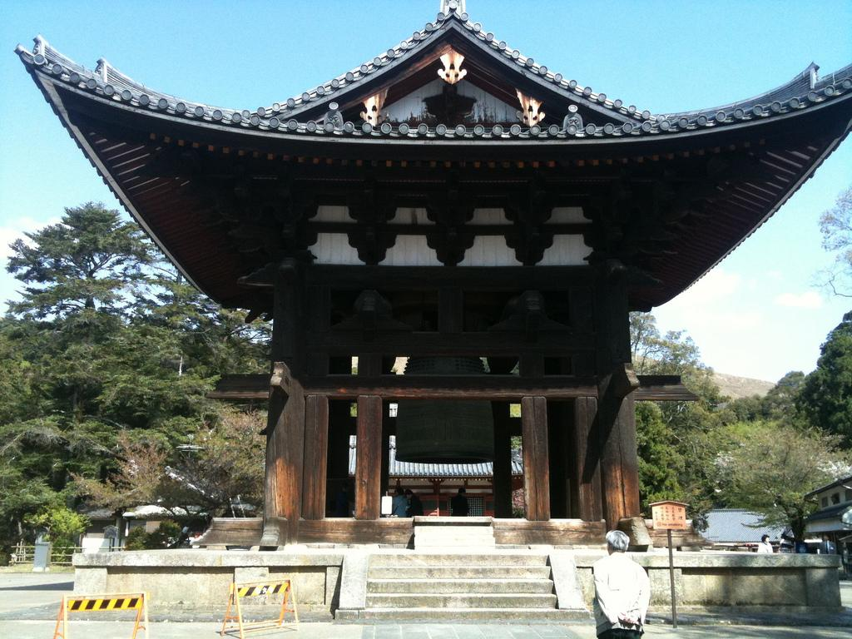
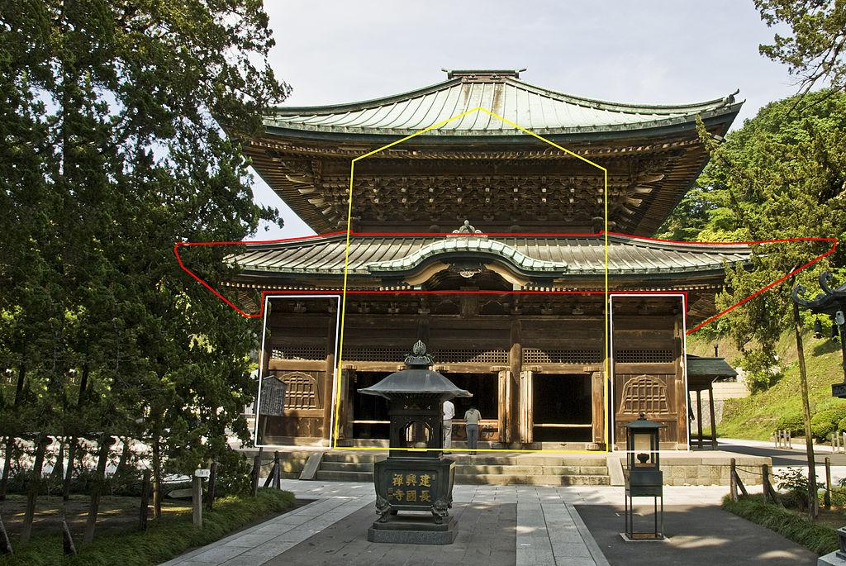
(Yellow: moya; red: mokoshi, white: hisashi)

- Muromachi Period
- The three styles we have seen (wayō, daibutsuyō and zen'yō) were often combined during the Muromachi period (1336–1573), giving birth to the so-called Eclectic Style ( setchūyō?), exemplified by the main hall at Kakurin-ji.PIC
- The combination of wayō and daibutsuyō in particular became so frequent that sometimes it is called by scholars Shin-wayō ( new wayō?).
- By the end of the Muromachi period (late 16th century), Japanese Buddhist architecture had reached its peak. Construction methods had been perfected and building types conventionalized
- Architecturally, the Muromachi period is best remembered for the construction of Zen temples. Notable examples are the so-called “Five Mountains” temples of Kyoto
- which were situated mainly around the outskirts of the city to take advantage of the mountain scenery that borders Kyoto on three sides
- Kamakura's five great Zen temples were already known as the Five Mountains and it unified in one organization all the great temples of the dominant Zen schools of the time. It thus institutionalized a large and very important part of the Rinzai school, bringing to it the protection, but also the control of the state
- 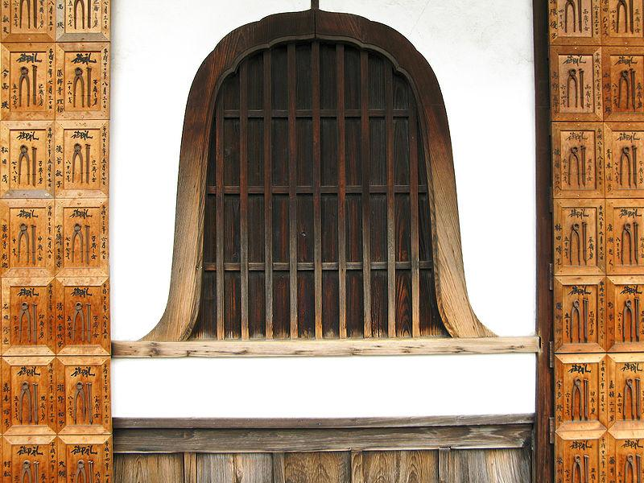
(cursped windows)
Painting:
- An important feature of the Kamakura period was the development of realistic character portraits
- Some of these, known as nise-e (likeness pictures), were sketch-like portraits, especially of persons of the court nobility.
- Introduced from China was the custom whereby a Zen priest would often bestow a portrait of himself, known as a chinzo, on an accomplished pupil as a certification of the latter's attainments
- These chinzo were often very realistic, conveying a sense of the subject's character and spirit
- Portraits were also drawn of such contemporary or former political figures as Minamoto no Yoritomo and Taira no Shigemori in full costume. Their manly forms and facial expressions were additions to the inventory of Japanese pictorial art
- Narrative handscrolls (emaki), too, showed a versatile development and included scenes taken from military romances and other literature as well as scenes from the lives of such well-known monks(male member of a religious order ) as Honen, Ippen, and Ganjin.
(1) Ippen Shonin Eden (Illustrated Biography of the Monk Ippen)
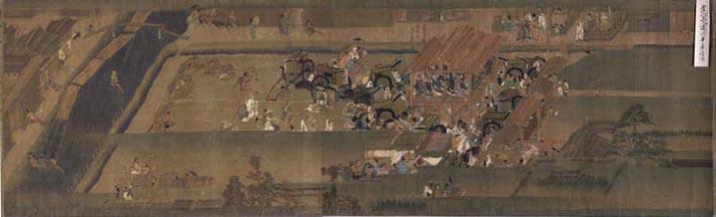
by En'i
Kamakura period, dated 1299
Handscroll, color on silk
Height 37.8 cm; Total length 802.0 cm
(Tokyo National Museum)
- This is the seventh of twelve consecutive handscrolls depicting the biography of the Kamakura period monk Ippen (1239-1289), founder of the Ji sect of Buddhism
- These narrative handscrolls together depict the whole life of Ippen, who traveled throughout Japan advocating the practice of nembutsu (reciting the name of the Buddha) to everyone, rich or poor, he met along the way up until the time of his death in present-day Hyogo Prefecture
- These scrolls faithfully depict temples and other places of note which Ippen visited, and their depictions of landscapes are said to show the influence of Chinese Song-dynasty landscape paintings.
- The written text included in these scrolls was composed, it is thought, by Ippen's disciple Shokai while the painting was done by En'i
- This seventh scroll of the series depicts Ippen's travels in Kyoto and neighboring areas.
(2) Portrait of Minamoto no Yoritomo
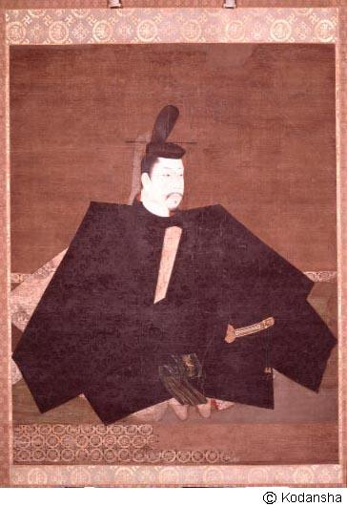
Kamakura period, late 12th century
Hanging scroll, color on silk
Height 143.0 cm; Width 112.8 cm
(Jingoji Temple, Kyoto Prefecture)
- This Kamakura period work, which has traditionally been thought to be a portrait of Japan's first shogun, Minamoto no Yoritomo, is a masterpiece of Japanese portrait painting and is kept at Jingoji Temple
- The subject is in formal dress, with a sword attached to his belt and with a staff in his right hand.
- The composition has a certain geometric simplicity and balance. The distinctly individual facial features and the overall form of the body, depicted to suggest dignity and authority, successfully express the youthful vigor(strength) and ambition of the subject.
- The artist is thought to be Fujiwara Takanobu (1142-1205), often called the founder of the portrait painting genre.

Sculpture(gods,godesse,shinto kami,creatures,demons)
- Kamakura period is regarded as 'Renaissance era of Japanese sculpture'. Kei school sculptures led this trend, who are descendents of Jōchō
- They succeeded the technique "yosegi-zukuri" (Woodblock construction) and represented new sculpture style: Realism, Representation of sentiment(emotions/attitude), Solidity, and Movement
- They use mainly wood and sometimes bronze.
- Kei school looted in Nara-city, Unkei is the most famous
He became the most influential artist of his time, and today is perhaps the most widely known artist of Buddhist sculpture in Japan
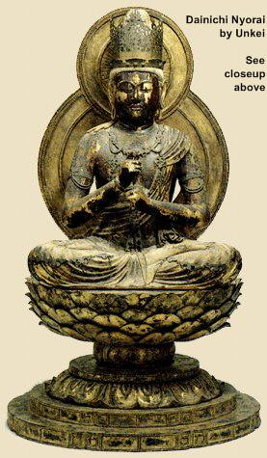
- Dainichi Buddha by Unkei
Unkei’s earliest known work
- Lacquer & gold leaf over wood.
- Height = 101 cm
- Dated +1176.
- Enjoji (Enjōji) Temple in Nara
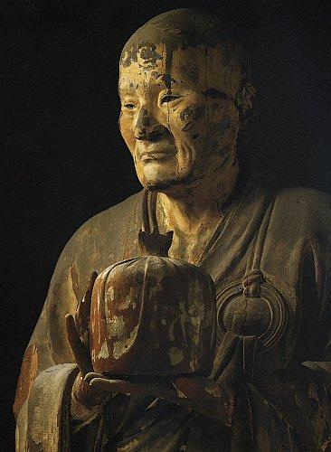
- Masterpiece of Realism & Portraiture
Asanga Carved by Unkei.
Indian Patriarch of Hosso (Hossō) 法相宗 Sect.
- H = 194.7 cm.
- Colored Wood.
- Dated around +1208.
Treasure of Kofukuji (Kōfukuji) Temple , Nara
- (Jokei). A member of the Kei school, although his lineage is unclear. Active in the late 12th and early 13th centuries. Curiously, another important sculptor of the period
- Jōkei is credited with creating his own unique style, blending both the realism of the Kei school with the artistic styles of Sung-dynasty China
- 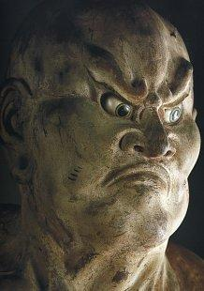

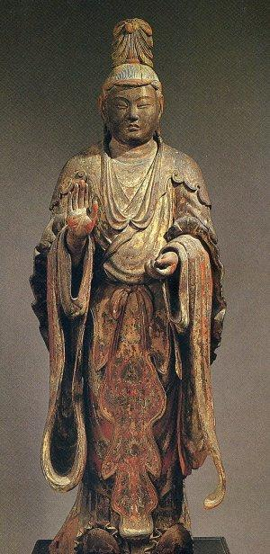
- Bonten , dated +1202, by Jōkei
Kōfukuji Temple, Nara.
- Wood,
- H = 181.3 cm, deeply carved folds & elegant robe.
Reflects artistic influence of China’s Song dynasty.
- Important Cultural Property

Azuchi-Momoyama period

During the Azuchi–Momoyama period (1568–1600) Japan underwent a process of unification after a long period of civil war

It was marked by the rule of Oda Nobunaga andToyotomi Hideyoshi, men who built castles as symbols of their power

The Ōnin War during the Muromachi period had led to rise of castle architecture in Japan

By the time of the Azuchi-Momoyama period each domain was allowed to have one castle of its own. Typically it consisted of a central tower or tenshu (heaven defense) surrounded by gardens and fortified buildings

All of this was set within massive stone walls and surrounded by deep moats. The dark interiors of castles were often decorated by artists, the spaces were separated up using sliding fusuma (are vertical rectangular panels which can slide from side to side ) panels and byōbu(with text on it) folding screens.

The shoin style(meant a study and a place for lectures) that had its origins with the chashitsu of the Muromachi period continued to be refined

Verandas linked the interiors of residential buildings with highly cultivated exterior gardens

Fusuma and byōbu became highly decorated with paintings and often an interior room with shelving and alcove(niche) (tokonoma) were used to display art work (typically a hanging scroll)

Matsumoto, Kumamoto and Himeji (popularly known as the White Heron castle) are excellent examples of the castles of the period, while Nijo Castle in Kyōto is an example of castle architecture blended with that of an imperial palace, to produce a style that is more in keeping with the Chinese influence of previous centuries

Two new forms of architecture were developed in response to the militaristic climate of the times: The castle, a defensive structure built to house a feudal lord and his soldiers in times of trouble; and the shoin, a reception hall and private study area designed to reflect the relationships of lord and vassal within a feudal society

Himeji Castle (built in its present form 1609), popularly known as White Heron Castle, with its gracefully curving roofs and its complex of three main towers around the main tenshu (or keep), is one of the most beautiful structures of the Momoyama period

The Ohiroma of Nijo Castle (seventeenth century) in Kyoto is one of the classic examples of the shoin, with its tokonoma (alcove), shoin window (overlooking a carefully landscaped garden), and clearly differentiated areas for the Tokugawa lords and their vassals
Himeji Castle in Himeji, Hyōgo
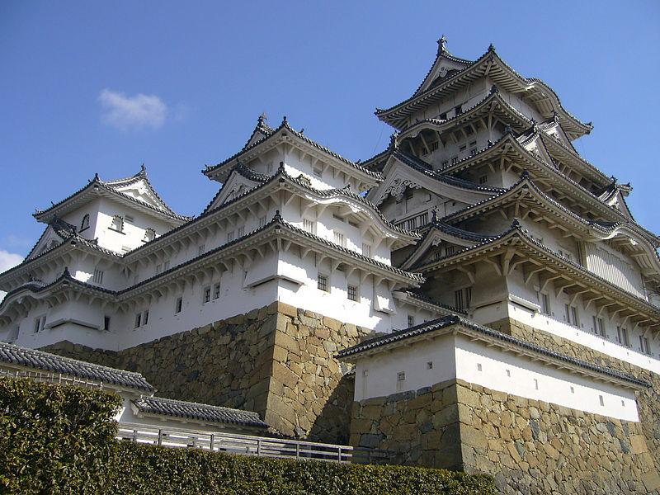
- Himeji Castle is the largest castle in Japan
- It serves as an excellent example of prototypical Japanese castle architecture, containing many of the defensive and architectural features associated with Japanese castles
- The curved walls of Himeji Castle are sometimes said to resemble giant fans ( sensu), but the principal materials used in the structures are stone and wood.
- Feudal family crests (紋 mon?)( encircling a figure of plant, animal, man-made, natural or celestial objects, all abstracted to various degrees ) are installed throughout the architecture of the building, signifying the various lords that inhabited the castle throughout its history
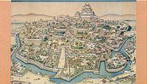
A depiction of the intricate castle complex
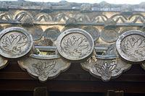
The family crest of Ikeda Terumasa
- The Himeji Castle complex is located in the center of Himeji, Hyōgo on top of a hill called Himeyama, which is 45.6 m (150 ft) above sea level
- The castle complex comprises a network of 83 buildings such as storehouses, gates, corridors, and turrets (楼 yagura?)( a small tower on top of a larger tower or at the corner of a building or wall, typically of a castle)
- Of these 83 buildings, 74 are designated as Important Cultural Assets: 11 corridors, 16 turrets, 15 gates, and 32 earthen walls
- The highest walls in the castle complex have a height of 26 m (85 ft). Joining the castle complex is Koko-en Garden (好古園 Kōkoen?), a Japanese garden created in 1992 to commemorate Himeji city's 100th anniversary
- From east to west, the Himeji Castle complex has a length of 950 to 1,600 m and from north to south, it has a length of 900 to 1,700 m
- The castle complex has a circumference of 4,200 m
- It covers an area of 233 hectares(2,330,000 m² or 576 acres)
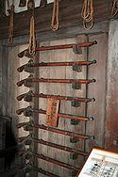
Weapon racks inside the keep
- Externally, the castle keep appears to have five floors, because the second and third floors from the top appear to be a single floor; however, the tower actually has six floors and a basement
- the interior of the keep contains special facilities that are not seen in other castles, including lavatories, a drain board, and a kitchen corridor
- The keep has two pillars, with one standing in the east and one standing in the west
- The first floor of the keep has an area of 554 m² and is often called the "thousand-mat room" because it has over 330 Tatami mats (thick rectangular mat of woven straw,)
- The walls of the first floor have weapon racks for holding matchlocks and spears, and at one point, the castle contained as many as 280 guns and 90 spears
- The second floor of the keep has an area of roughly 550 m²
- The third floor has an area of 440 m² and the fourth floor has an area of 240 m²
- Both the third and fourth floors have platforms situated at the north and south windows called "stone-throwing platforms" ( ishiuchidana?), where defenders could observe or throw objects at attackers
- They also have small enclosed rooms called "warrior hiding places" ( mushakakushi?), where defenders could hide themselves and kill attackers by surprise as they entered the keep
- The final floor, the sixth floor, has an area of only 115 m²
- The sixth floor windows now have iron bars in place

Painting

In the Momoyama period (1573-1603), a succession of military leaders, including Oda Nobunaga, Toyotomi Hideyoshi, and Tokugawa Ieyasu, attempted to bring peace and political stability to Japan after an era of almost 100 years of warfare

The most important school of painting in the Momoyama period was that of the Kanō school

Kanō painters often worked on a large scale, painting nature scenes of birds, plants, water, or other animals on sliding doors or screens, covering the background with gold leaf

The school is equally renowned for its monochrome ink-on-silk landscapes, flat pictures that balance impeccably detailed realistic depictions of animals and other subjects in the foreground with abstract,

often entirely blank, clouds and other background elements.

The greatest innovation of the period was the formula, developed by Kano Eitoku, for the creation of monumental landscapes on the sliding doors enclosing a room.

The decoration of the main room facing the garden of the Juko-in, a subtemple of Daitoku-ji (a Zen temple in Kyoto), is perhaps the best extant example of Eitoku's work PIC

A massive ume tree and twin pines are depicted on pairs of sliding screens in diagonally opposite corners, their trunks repeating the verticals of the corner posts and their branches extending to left and right, unifying the adjoining panels

Eitoku's screen, Chinese Lions, also in Kyoto, reveals the bold, brightly colored style of painting preferred by the samurai
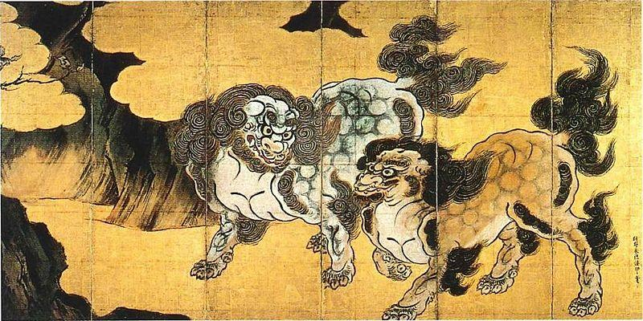
Chinese Lions (Karajishi),at the Museum of the Imperial Collections
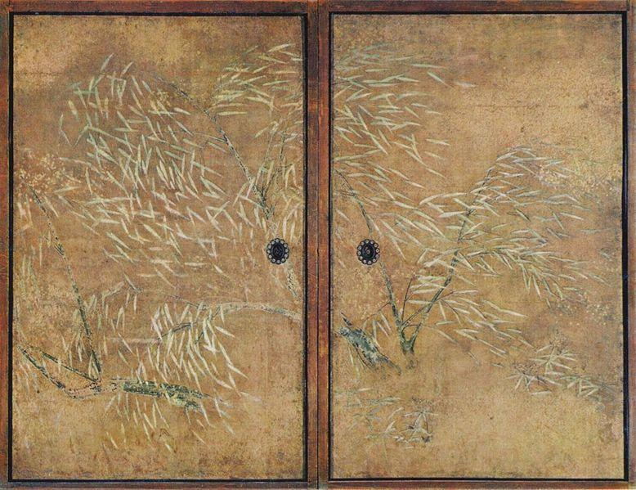
Trees on sliding doors

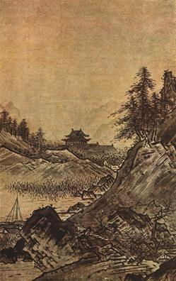
Autumn Landscape, by Sesshu Toyo

Sculpture:

Prince Shotoku
Asuka-dera, Japan
- Shotoku, the grandson of Umako, was prince regent and a great supporter of Buddhism who founded Horyu-ji temple
- This statue is located to the left of Shaka in the Asuka-dera.
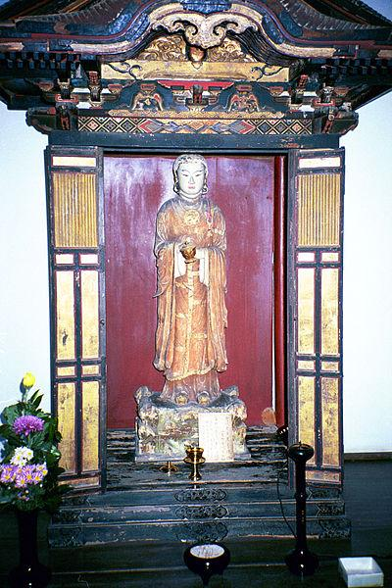

12 Godly Generals
- To-ji Temple
Kyoto, Japan
- Each General wears different expressions and attributes
- The color and detailing of their uniforms is carefully applied
- The Martins attribute these statues to "Kosho," but they do not specify whether they mean Kosho the father of Jocho (Heian period), or Kosho the son of Unkei (Kamakura period)
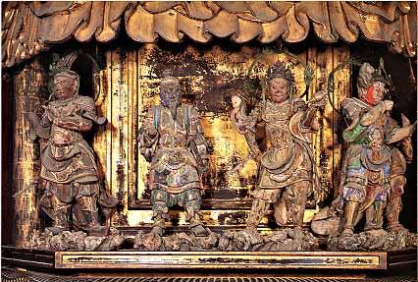

Yakushi Triad
- Momoyama Period, 1603
To-ji Temple
Kyoto, Japan
- This statue of Yakushi, the Buddha of Healing, replaces a Heian original lost in the fire of 1486.
- Located in the Kondo of the temple, it is edged by statues of Nikko (Sunlight Bodhisattva) and Gakko (Moonlight Bodhisattva), not seen in this photograph
- Underneath the platform are statues of the 12 Godly Generals.
- The 12 Generals are protectors of Buddhism.
- They have symbolic relationships to Yakushi's 12 Vows, and also to the zodiac, such that a person's birth sign places him under the protection of the corresponding Genera.

Elements of a Traditional Japanese Interior
Evolution of Architecture and Interior Styles
- From the Heian period through the mid Edo Period (792- 1750) there were three major residential architectural styles which evolved:
- shinden -zukuri,
- shoin -zukuri, and
- sukiya -zukuri. Shinden-zukuri

SHINDEN-ZUKURI 19th century version of the Imperial Palace in Kyoto
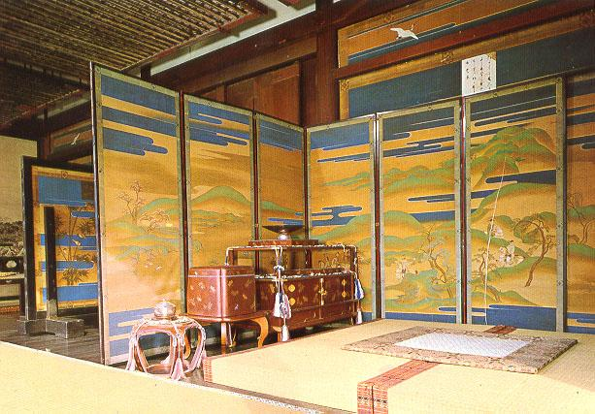
- Residential dwellings of the nobility first appeared in the Heian period with the shinden zukuri style of architecture.
- Shinden style copied the example of the Buddhist temple worship halls. It was copied from the T'ang dynasty bisymmetrical structures.
- The halls are connected to one another by roofed passageways.
- The interior of the shinden style was also like worship halls which were open except for round pillars.
- The center of the main hall was called the moya and was surrounded by two sets of pillars.
- The interior space was partitioned through the clever use of folding screens, byobu, reed curtains, sudare and curtain stands, kicho.
- The flooring was wooden planks.
- There were cushions and rush mats used for sitting and sleeping.
- There was a small room called the nurigome used for sleeping or storage.
- This style was used by the nobility and high ranking samurai through the mid 15th century.
- This style afforded little protection from the cold winters which accounted for the many layers of clothing which was the style of the time

Shoin-zukuri
- shoin was originally the name given to the abbot's quarters in a Zen temple.
- Shoin means library or study. The oldest extant example of shoin- zukuri is the Dojinsai room in the Togudo at Ginkakuji (Silver Pavilion). This small room was built by Ashikaga Yoshimasa in 1486.
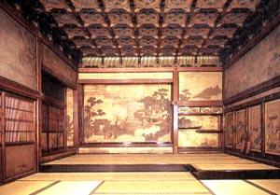
- The shoin style eventually became a grand and large setting meant for the pomp of the feudal warlords.
- It was a larger, massive feeling with much ornamentation.
- The utilization of square cut pillars (as opposed to the round of the shinden style) allowed sills and lintels to be easily installed between them.
- This, in turn, expanded the ways interior space could be partitioned through the use of shoji and fusuma panels.
- Tatami began to cover the entire floor area with some rooms over one hundred tatami in size.
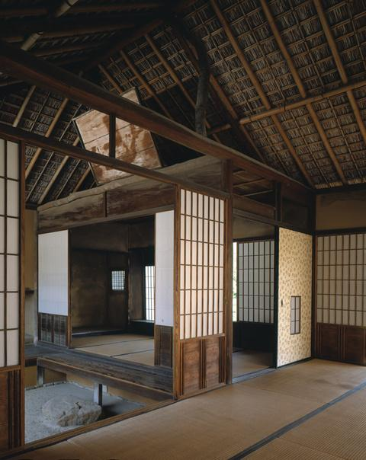
Sukiya-zukur
- The sukiya style came from the tea ceremony, in fact the word sukiya refers to the building in which the tea ceremony is performed.
- The sukiya style which evolved from the Azuchi- Momoyama period and shoin style, was in direct contrast to the grand and magnificent settings of the shoin-zukuri.
- In the sukiya, the smaller and simpler is considered the best design.
- Some tea huts went from six tatami down to 1 3/4 tatami in size.
- Sukiya style combined a smaller, simpler setting with the features of a more delicate, natural and unornamented style
- It is this style that most represents the traditional Japanese interior
- . The classical example of sukiya-zukuri is the Katsura Imperial Villa (Detached Palace)

MAIN ELEMENTS
Floors/Tatami
- People of the Jomon period (30,000B.C -300B.C.) were pit dwellers. They dug rectangular holes in the ground and covered them by leaning logs against posts and ridge poles. The dirt floors were covered with straw.
- Toward the end of the subsequent Yayoi period (ca. 300A.D.) raised floors began to be built to house grain. The benefits of raised floors in the granaries was not wasted on the nobility who began living in such structures.
- From that time on, the ruling classes always lived in structures elevated from the ground. The lower classes remained living on mat covered dirt floors for many centuries to come. The predominant flooring for the nobility was wooden planks. Their elevation from the ground raised the inhabitants from the dampness and provided ventilated relief from the hot humid summers.Seating was at floor level.
- From the Kofun period to the Heian period seating was usually on round, thick straw woven mats called warouda. This was done through tatami type mats. The word tatami comes from the verb tatamu, which means to fold or pile up.
- During the Heian period okitatami were thin mats which were used only in isolated areas. Again the flooring was predominately the wooden planks. Okitatami were versatile, they could be used for cushions, stools, and sleeping mats depending on whether they were folded or not. Piling the tatami up higher indicated the ranking of court individuals. Also cloth edging color and design were also an indication of rank in the court.
- By the Muromachi period, tatami had evolved into the form with which we are familar, a thick mat base of woven rice straw, toko, covered by woven rush, igusa.. Tatami size is said to have been determined by the sleeping area of a person
- Every several years tatami should be stripped of the woven rush cover and recovered by a professional tatami maker. When the new covering is first put on, it is a beautiful green color, which eventually changes to a yellow straw color when exposed to any sunlight. Sleeping on new tatami smells like sleeping on new mown hay.
- Depending on the number, tatami can be placed into a number of different patterns. Tatami have to be periodically aired out to prevent mold or mildew. Newer tatami are now made with bases of polystyrene instead of rice straw. These are usually lighter and less susceptable to mold but do not have quite the same feeling underfoot. Neither shoes nor slippers are to be worn while walking on tatami. Tatami can be maintained by wiping them with a damp cloth or vacuuming

Shoji/ Fusuma
- The advantage of post and beam construction is that there are no bearing walls. The fact that the building's load is taken by the pillars frees the walls and interior partitions to be not only light in weight but also mobile as well.
- Fusuma are the opaque sliding doors seen in the interior of the house.Their function in the house is two-fold. They partition the interior rooms of the house and they provide artistic decoration since they are usually painted with a scene of some sort
- Shoji are the lattice frame sliding doors which are covered with translucent paper made from mulberry bark (sorry, rice paper is a misnomer). They usually partition the interior from the exterior, and subsequently the outer bounderies of the tatami. Walking on the tatami side of the shoji requires bare or stocking feet; on the other side slippers or shoes are acceptable. Shoji's translucence allows diffused light to filter into the house. It also provides the observer an patterns of shadow and light.
- The transformation into fusuma and shoji took hundreds and hundreds of years. The first partitions followed the example of the outer doors which were plank boards placed in a frame. The boards were eventually covered with heavy paper which could be used as a decorative canvas for an artist. The boards eventually gave way to a lighter lattice frame around the early Heian period.
Ramma
- Ramma, or transom pieces, are used to decoratively fill those spaces is usually in between the runners, lintel and ceiling..
- They also serve the practical purpose of allowing ventillation and light into the interior of house. Ramma can be carved three dimensional scenes, slatted wood or small sliding shoji panels

Ceilings
- The tendency in Japan was to lower the ceiling height as the floor space became smaller.
- There are several reasons for this.
- First is that the living style was at floor level so perception of the ceiling height was different from that of chair levels.
- The other reason has always been that "high ceilings make for cold winters and dim lighting" as Yoshida Kenko stated during the Kamakura period
- Most traditional rooms are based on the sukiyazukuri, in other words, based on the tea ceremony hut.In the typical tea room there are various ceiling heights from the entrance to the middle to the position of the host's tea preparation area. Not only are the heights different, the style of ceiling can change as well. In the tea room the style follows the shin-gyo-so aesthetic, flowing from formal into informal.

